Abstract for CLES/LANSA’17 (title with 14 pt, Bold)

Taro YOKOHAMA ¹, and Hanako KANAGAWA ² (12pt)
1) Institute of Neutron Science, Pacifico University, Japan (12pt italic)
2) Neutron Engineering Laboratory, Japan
E-mail;email@your.institute

The Conference on Laser Energy Science / Laser and Accelerator Neutron Sources and Applications 2017 (CLES/LANSA’17) [1] will be held at Pacifico Yokohama, Yokohama Japan, on April 18 (Tue) - 21 (Fri), 2017.
Abstract should be written in clear English on an A4 size paper (297×210 mm) with a 25 mm margin on all sides. The text should be typed in one column format with 12 pt font size. “Times New Roman” font or equivalent is recommended. The total length will be limited to ONE page for all presentations. Page number should not be added for easily making the abstract book.

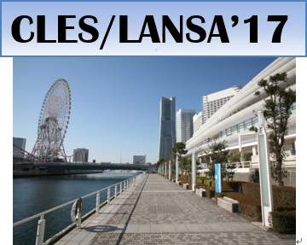
Figure 1: CLES/LANSA’17.

Abstract submission can be made via registration Web site. Please prepare a PDF file of your abstract which should involve all fonts and graphics used in the file. The authors are requested to check the computer file by themselves. Then, please submit the PDF file to the submission site ( http://paper.opicon.jp/lansa_paper/ ) no later than December 12, 2016.

References
[1] Web page of CLES/LANSA’17 (http://lansa.opicon.jp).

